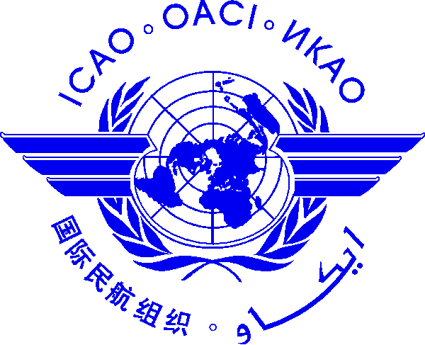 |  | International Civil Aviation Organization  Cooperative Development of Operational Safety and Continuing Airworthiness Programme (COSCAP)  State Safety Programme (SSP) Implementation Course  (ICAO Asia and Pacific Office, Bangkok, Thailand, 7 - 11 November 2016)  Please register by: 28 October 2016

Nomination Form [please type or print]

State/ Organization
Name | Title |  | Family name (capitals) | First name | Middle initial
□ Mr.:
□ Ms.:
□ Mrs.:
□ Other:
Official Position
Mailing Address
Telephone (office)
Fax
(office)
E-mail
Hotel in Bangkok
Date

NOTE: Participants are expected to make their own hotel and visa arrangements.

After completing, please send to:  COSCAP-SEA Programme Secretary  E-mail: khun.nong@coscap-icao.org  Fax International: +66 2 287 0805 | Copy to:  ICAO Asia and Pacific Office  E-mail: apac@icao.int  Fax International: +66 2 537 8199

